Kem Chan
CS 405 Secure Coding
Sept 28, 2026
Assignment 5 – Encryption

Output Screenshots
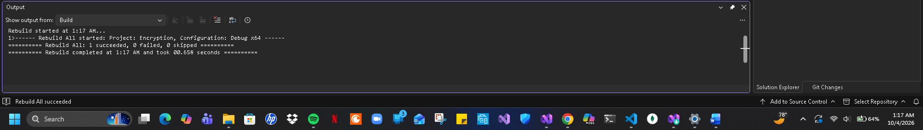
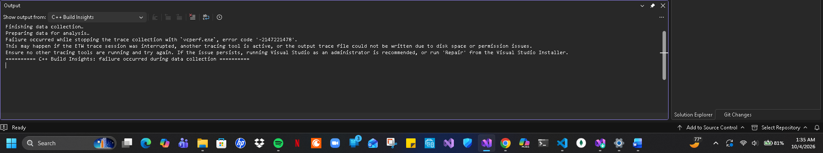
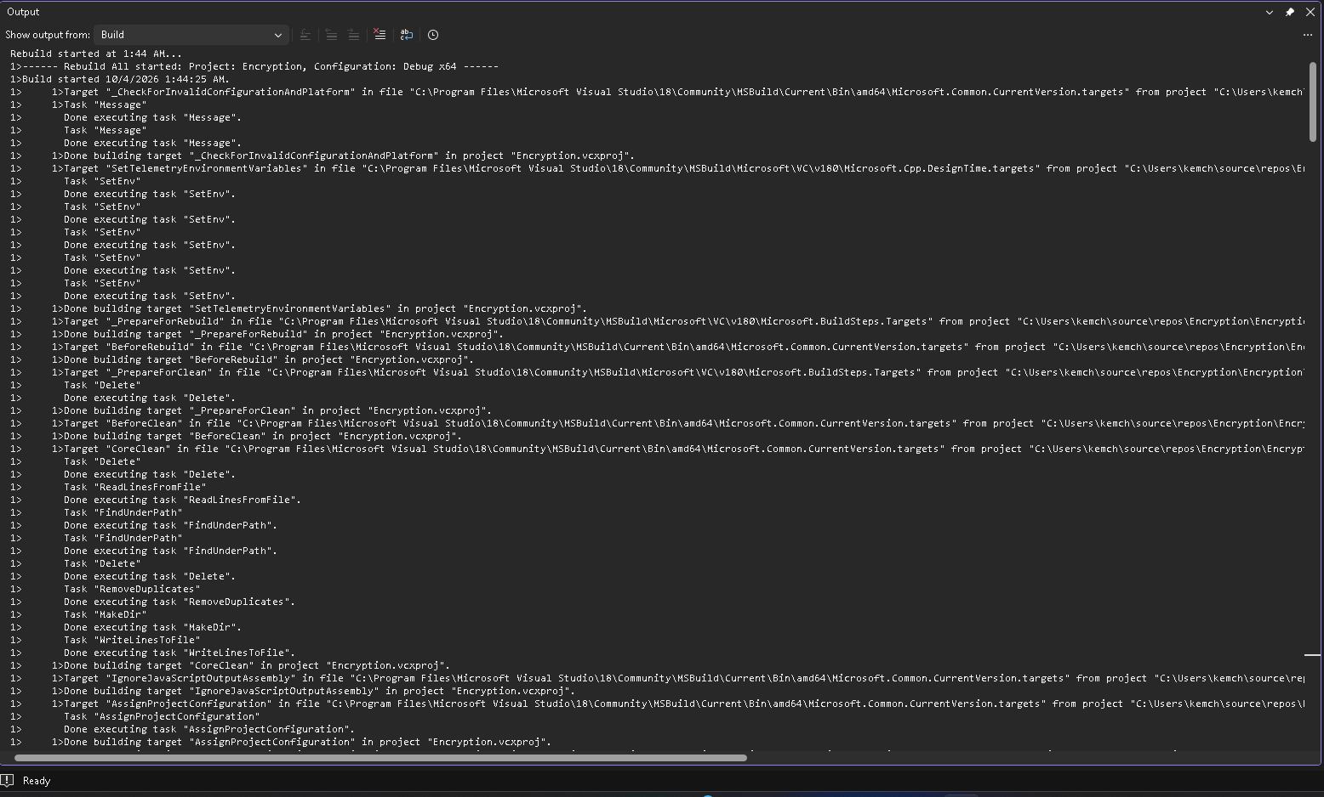
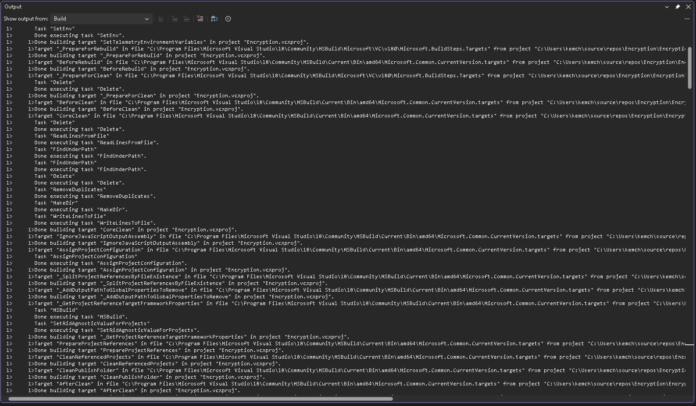
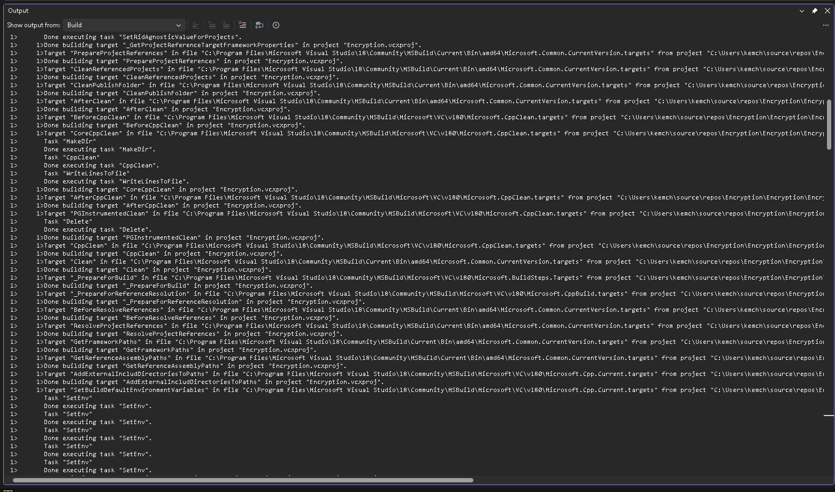
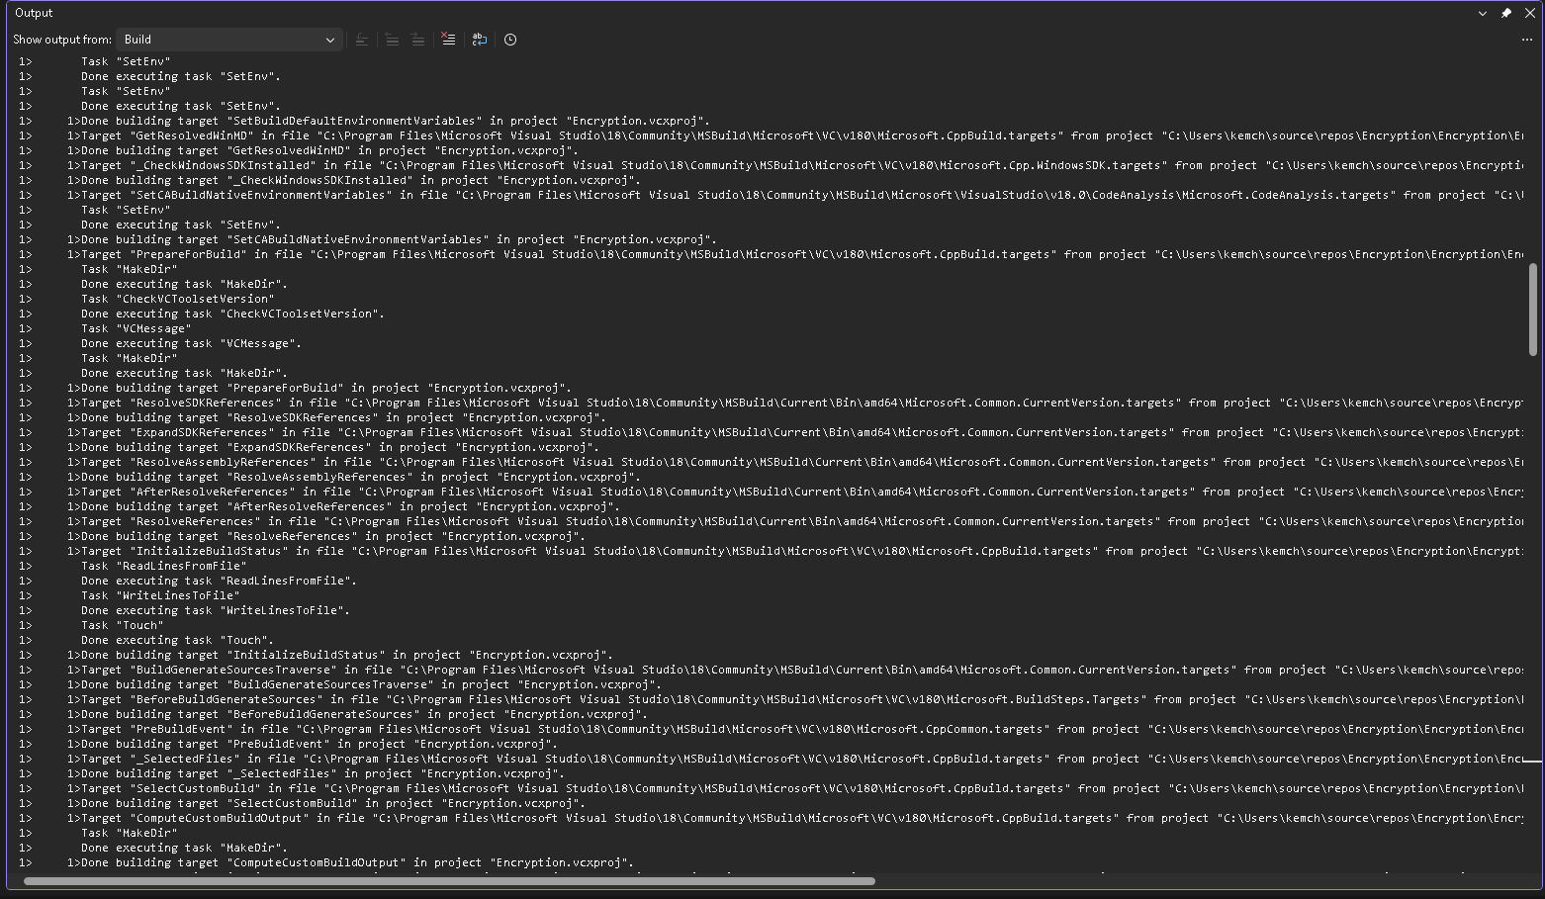
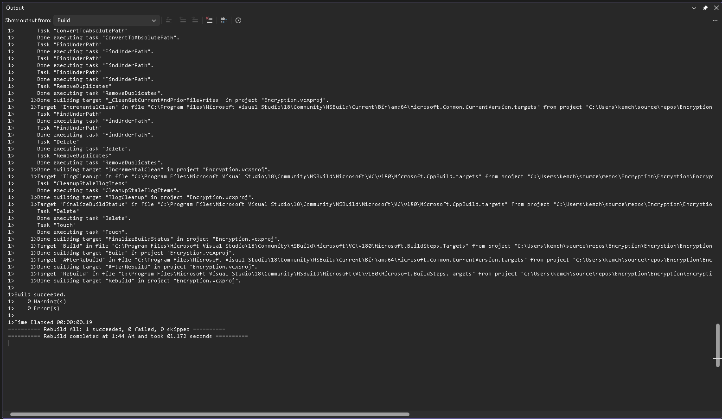
Input data file
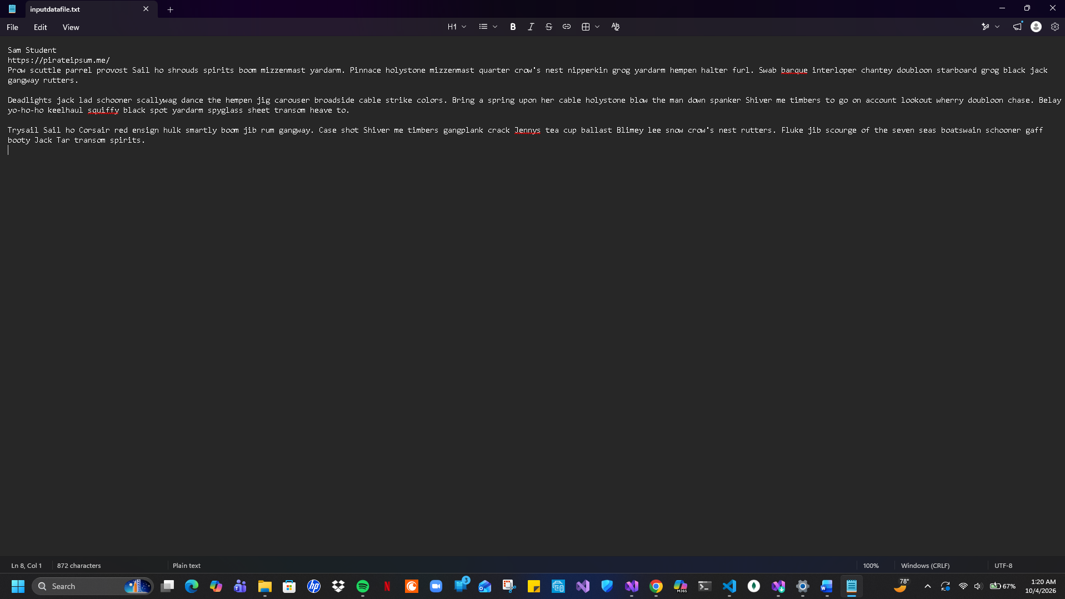

Summary
The program provided is to change the provided file reader to read all of the content specified text file into a string and promptly close the file. From this moment the encrypt / decrypt method should be called to take the string value to be encrypted and transferred onto a new text file. Then it would open the file and read the encrypted content to then be retrieved from storage and run through the encrypt / decrypt method with the intent to decrypt the method. Lastly, the decrypted file should be saved onto a separate file as well.

